Design and Simulation of a Digital Clock Using Multisim

Project Report
Submitted in partial fulfillment
of the requirements for the course
Digital Logic [Code: EX 235]

Submitted By Submitted To
Kishor Bhatt [81BCT21] Er. Kamal Lekhak
Amrit Bhatt [81BCT04] (Instructor)
Vivek Bhatt [81BCT47]

Date: 2083/02/07

APPROVAL SHEET
This project report titled “Design and Simulation of a Digital Clock Using Multisim” is submitted by the Team(Kishor Bhatt, Amrit Bhatt, Vivek Bhatt) and has been reviewed and approved by the following:
Supervisor/Instructor: ______________________________
Signature: ______________________________
Date: ______________________________

ACKNOWLEDGEMENT
We would like to express my sincere gratitude to our instructor and lab supervisor for their valuable guidance, constant encouragement, and insightful feedback throughout this project. Their expertise helped us understand complex digital design concepts in a practical way. We are also thankful to our seniors for providing the necessary resources and support during the simulation work. Finally, I thank our family and friends for their patience and motivation.

INTRODUCTION
Digital clocks are everywhere in our daily live - from microwaves and watches to public displays and industrial timers. At their core, they rely on sequential logic circuits that count electrical pulses and convert those counts into readable time formats. Building one from scratch gives you a hands-on understanding of how counters, decoders, and display drivers work together.
In this project, we design and simulate a 24-hour digital clock that counts seconds (00-59), minutes (00-59), and hours (00-23). Instead of building the physical circuit with real chips and wires (which can be time-consuming and prone to connection errors), we use National Instruments Multisim simulation software. Multisim lets us test the complete circuit virtually, observe waveforms, debug logic issues quickly, and verify behavior under different conditions before any hardware implementation. This approach saves time, reduces costs, and helps us focus on understanding the logic.
Decade Counter using JK Flipflop
An asynchronous decade counter counts from 0 to 9 (decimal) and then resets to 0. It requires 4 flip-flops because 2^4=16 states, more than enough to count up to 9.

Components:
- 4 JK flip-flops, labeled FF0 (LSB) to FF3 (MSB)
- Clock input

JK Flip-Flop Configuration:
- For toggle operation, both inputs J and K are tied to logic HIGH (1) so that on every triggering edge, the flip-flop toggles its state.

Step-by-Step Design:
- First Flip-Flop (FF0):
  - Connect the clock input signal to the clock input of FF0.
  - J and K inputs tied to 1.
  - FF0 toggles every clock pulse (counts units).
- Second Flip-Flop (FF1):
  - Connect the clock input of FF1 to the output Q of FF0.
  - J and K tied to 1.
  - FF1 will toggle on the falling/rising edge (depending on flip-flop type) of FF0's output, counting 2s.
- Third Flip-Flop (FF2):
  - Connect clock of FF2 to Q of FF1.
  - J and K tied to 1.
- Fourth Flip-Flop (FF3):
  - Connect clock of FF3 to Q of FF2.
  - J and K tied to 1.

Reset Logic to Make it a Decade Counter:
- The counter must reset to zero on count 10 (binary 1010).
- Detect the count 1010 by connecting Q1 and Q3 outputs to an AND gate (since bits are numbered from Q0 to Q3).
  - Output of AND gate goes to the asynchronous clear (reset) inputs of all flip-flops.
- When count reaches 1010 (decimal 10), the AND gate output triggers the reset, bringing the counter back to 0000.
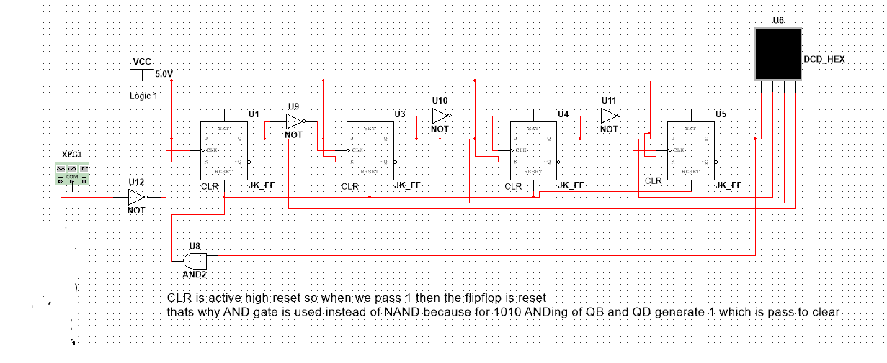

IC7490 Decade Counter

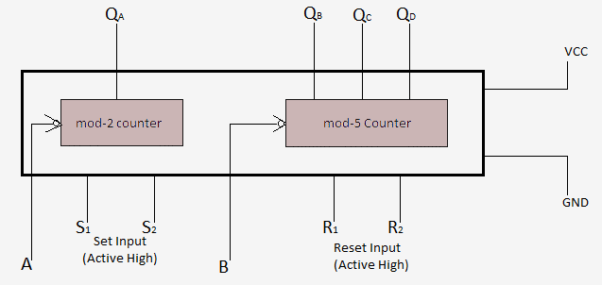
The 7490 (often suffixed with N for plastic dual-in-line packaging) is a classic TTL decade counter and frequency divider. It is used in digital circuits to count up sequentially from 0 to 9 and output the result in Binary-Coded Decimal (BCD).
How It Works
- The Core Elements: Internally, the 7490 consists of two independent parts:
  - Divide-by-two section: A single flip-flop that divides the incoming frequency by 2.
  - Divide-by-five section: A 3-bit flip-flop circuit that divides the incoming frequency by 5.
- Cascade for MOD-10 (Decade) Counting: By externally connecting the output of the divide-by-two section to the clock input of the divide-by-five section, you get a full MOD-10 (modulo-10) counter.
- Counting Sequence: Each time a clock pulse (square wave) goes from high to low, the counter advances. It counts from 0 to 9, outputting a 4-bit binary code ((QD, QC, QB, QA)). On the 10th pulse, the outputs naturally reset to 0000 and the process starts over.
- Reset & Set Pins: The chip has two sets of master reset pins ((R0(1), R0(2))) and master set pins ((R9(1), R9(2))). Grounding the reset pins allows normal counting. Raising both reset pins to HIGH instantly forces the counter to 0000, while setting both set pins HIGH forces it to 1001 (decimal 9)
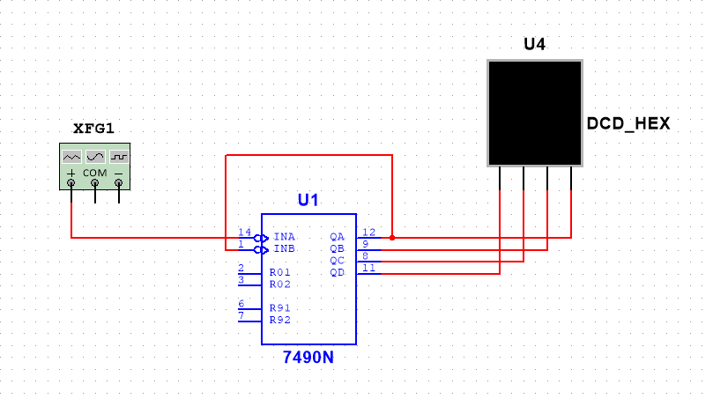

IC7447 Decade Counter
The 7447 IC is a popular BCD (Binary-Coded Decimal) to 7-segment decoder and driver chip. It takes a 4-bit binary input (0-9) and automatically converts it into the necessary electrical signals to display that number on a 7-segment LED display.
How It Works
- The Inputs (Pins 1, 2, 6, 7): You feed the IC 4-bit binary code (representing numbers (0) through (9)) using inputs labeled (A, B, C), and (D).
- The Outputs (Pins 9-13, 15, 16): Inside the IC, combinational logic gates process the binary input. It then sends the correct voltage out to the 7 corresponding segments of the display (labeled (A) through (G)) to illuminate the corresponding number.
Special Control Pins
- Lamp Test (Pin 3): When set to LOW, this turns on all segments simultaneously to test if any LEDs are broken.
- Blanking Input (Pin 4): Pulling this LOW turns off all segments, regardless of the binary input.
- Ripple Blanking (Pins 4 & 5): Used in multi-digit displays to suppress unnecessary leading or trailing zeros (e.g., displaying "5" instead of "005").
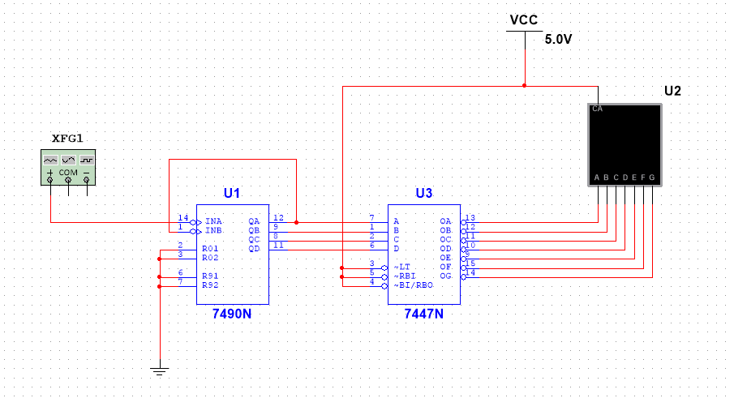

Cascading Two IC7490 for MOD-100 counter
Cascading two 7490 ICs is a way to build a MOD-100 counter (counting from 00 to 99). To count 99 seconds, provide a precise 1Hz clock (one pulse per second) to the first IC. The setup requires connecting the counters in series.
1. Configure the Units Counter (0-9)
The first 7490 IC tracks the seconds from 0 to 9.
- Connect the1Hz clock source to Pin 14 (CLKA).
- Internally cascade to the divide-by-five section by connecting Pin 12 (QA) to Pin 1 (CLKB).
- Ground Pins 2, 3, 6, and 7 (the Reset/Set pins) so the counter advances normally.
2. Configure the Tens Counter (0-9)
The second 7490 IC counts the tens digit.
- Cascade the counters by connecting Pin 11 (QD) or the most significant bit of the Units IC) to Pin 14 (CLKA) of the Tens IC.
- Just like the first IC, bridge Pin 12 (CLKA) to Pin 1 (CLKB) to engage the full decade cycle.
- Ground Pins 2, 3, 6, and 7 on this IC as well.
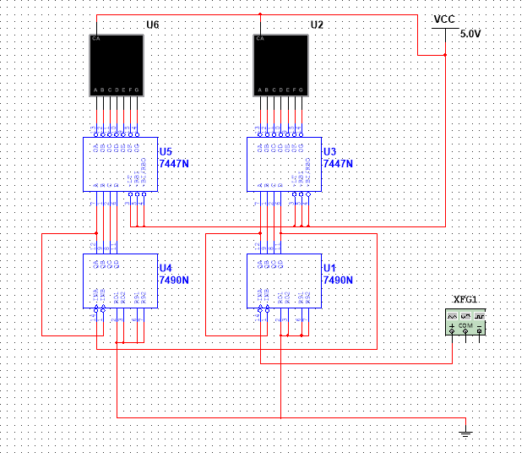

Making Second Counter (00 to 59)
To modify your circuit to count from 00 to 59 and automatically loop back to 00, you must add an external AND gate (like the 7408 IC) to reset the tens digit when it reaches 6.
The units digit (0–9) remains unchanged, but the tens digit must reset immediately upon hitting 6 (binary 0110).
Required Hardware Update
- 1 x 7408 IC (Quad 2-Input AND Gate)
Rewiring Steps
- Isolate Tens Reset Pins: Disconnect pins 2 and 3 (R01) and (R02) of the Tens 7490 from Ground.
- Connect AND Gate Inputs: Connect QB (pin 9) and QC (pin 8) of the Tens 7490 to the two inputs of one AND gate
- Connect AND Gate Output: Connect the output of that AND gate to both pin 2 and pin 3 (R01 and R02) of the Tens 7490.
- Set-9 Pins to Ground: Ensure pins 6 and 7 (R91 and R92) of both ICs remain connected to Ground.
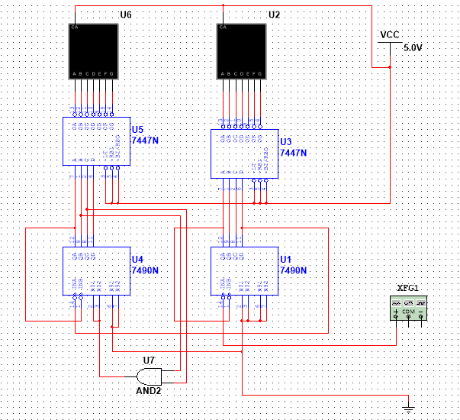

Making Minute Counter (00 to 59)
To expand your circuit to count minutes, you need to duplicate your 00–59 seconds stage to create a 00–59 minutes stage. You will cascade the seconds stage into the minutes stage so that the minutes increment exactly when the seconds roll over from 59 to 00.
Additional Components Needed
- 2 x 7490 ICs (Minute Units, Minute Tens)
- 2 x 7447/7448 Display Decoders
- 2 x 7-Segment Displays
- 1 x 7408 AND gate
Step-by-Step Wiring Guide
1. Cascade Seconds to Minutes
To make the minutes count, you must use the reset signal of your seconds stage as the clock for your minutes stage.
- Connect the output of your Seconds AND gate (the line triggering pins 2 and 3 of the Seconds Tens 7490) to CLKA (pin 14) of the Minutes Units 7490.
2. Wire the Minutes Units Stage (0–9)
This stage behaves just like your seconds units display.
- Connect QA (pin 12) to CLKB (pin 1) on the Minutes Units 7490.
- Connect QD (pin 11) of the Minutes Units 7490 to CLKA (pin 14) of the Minutes Tens 7490.
- Connect pins 2, 3, 6, and 7 of the Minutes Units 7490 directly to Ground.
3. Wire the Minutes Tens Stage (0–5 Loop)
This stage requires its own reset logic to loop at 6, just like your seconds tens display.
- Connect QA (pin 12) to CLKB (pin 1) on the Minutes Tens 7490.
- Connect pins 6 and 7 of the Minutes Tens 7490 to Ground.
- Connect QB (pin 9) and QC (pin 8) of the Minutes Tens 7490 to the inputs of a second AND gate.
- Connect the output of this second AND gate to both pin 2 and pin 3 (R01 and R02) of the Minutes Tens 7490.
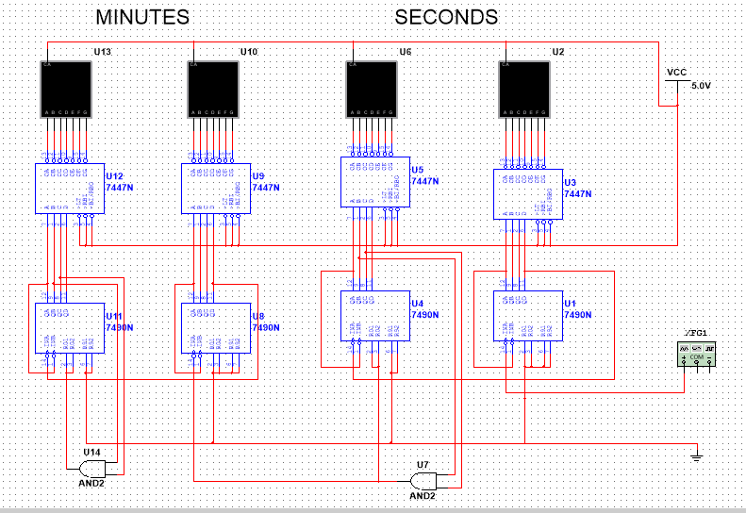

Final Hour Counter (00 to 23 format)
To complete your digital clock, you need to configure the hours section to count from 00 to 23 and instantly reset to 00 when it attempts to hit 24.
Unlike seconds and minutes, the hours stage cannot treat the units and tens digits independently. We must use a combined logic circuit because the units digit behaves differently depending on what the tens digit is showing.

Why the Logic is Different (The "Why" Behind the Format)
- For Seconds and Minutes (00 to 59): The units place always counts 0 to 9, and the tens place always counts 0 to 5. They are completely independent loops.
- For Hours (24-Hour Format):
  - When the Tens digit is 0 or 1, the Units digit must count a full Mod-10 (0, 1, 2... up to 9).
  - When the Tens digit reaches 2, the Units digit is strictly restricted. It must only count up to 3 (Mod-4). The moment it tries to hit 24, the whole hours section must reset.
Therefore, we need an AND gate to detect the exact moment Hours Tens = 2 AND Hours Units = 4.
Additional Components Needed
- 2 x 7490 ICs (Hours Units, Hours Tens)
- 2 x 7447/7448 Display Decoders & Displays
- 1 x 7408 AND gate
Step-by-Step Wiring Guide
1. Connect the Clock Trigger
The hours must increment exactly when the minutes roll over from 59 to 00.
- Connect the output of your Minutes AND gate (the line triggering pins 2 and 3 of the Minutes Tens 7490) to CLKA (pin 14) of the Hours Units 7490.
2. Basic Internal Wiring (Both Hours ICs)
- Hours Units: Connect QA (pin 12) to CLKB (pin 1). Connect pins 6 and 7 to Ground.
- Hours Tens: Connect QA (pin 12) to CLKB (pin 1). Connect pins 6 and 7 to Ground.
- Cascade Tens: Connect QD (pin 11) of Hours Units to CLKA (pin 14) of Hours Tens.
3. Wire the "24-Hour Reset" Logic
You must decode the number 24 using binary tracking:
- The number 4 on Hours Units is represented by QC (pin 8). →Because Format is 0100 (QD,QC,QB,QA)
- The number 2 on Hours Tens is represented by QB (pin 9). → Because Format is 0010(QD,QC,QB,QA)
We must send a reset pulse to both ICs simultaneously when these pins both go HIGH:
- Connect QC (pin 8) of Hours Units to Input 1 of a spare AND gate
- Connect QB (pin 9) of Hours Tens to Input 2 of that same AND gate
- Take the output of this AND gate (pin 8 of 7408). This is your Master Hours Reset Signal.
- Connect this Master Reset output to all four reset pins of the hours stage:
  - Pins 2 and 3 (R01 and R02) of Hours Units 7490.
  - Pins 2 and 3 (R01 and R02) of Hours Tens 7490.
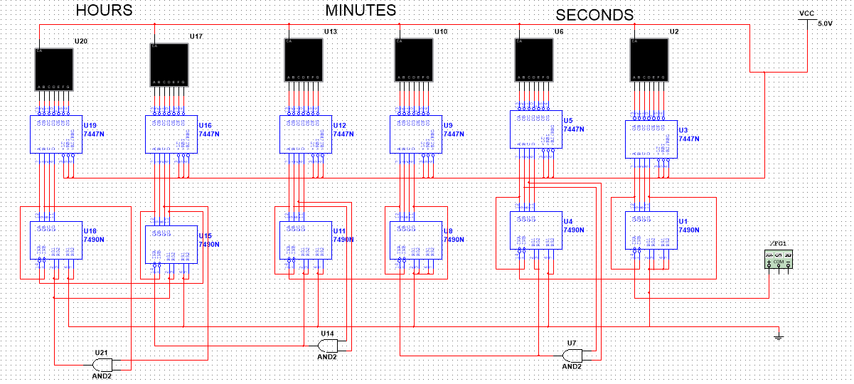

Final clock with manual button
To add manual buttons for advancing hours and minutes independently of the main clock, you need a way to feed a "pulse" into the inputs of those stages manually.
Hardware Needed
- 2 x Push-button switches (Normally Open) like spdt or spst
- 2 x 10k ohm resistors (Pull-down resistors)
- 1 x 7432 OR gate IC.

Step-by-Step Implementation
1. Build the Manual Button Circuits
First, build two independent, clean manual pulse buttons on your breadboard. For each button (Minutes and Hours):
- Connect one side of the push button to the +5V supply.
- Connect the other side of the push button to a 10k ohm resistor, and connect the other end of that resistor to Ground.
- The junction between the button and the resistor is your Manual Pulse Signal. (When you press the button, this point goes HIGH. When released, the resistor pulls it safely to LOW).
2. Route the Signals Using Logic Gates
If you have a 7432 OR gate handy:
- For Minutes Fast-Check:
  - Disconnect the Seconds AND gate output from Pin 14 (CLKA) of the Minutes Units 7490.
  - Connect that Seconds AND gate output to Input 1 of an OR gate.
  - Connect your Manual Minute Button to Input 2 of that same OR gate.
  - Connect the Output of that OR gate directly to Pin 14 (CLKA) of the Minutes Units 7490.
- For Hours Fast-Check:
  - Disconnect the Minutes AND gate output from Pin 14 (CLKA) of the Hours Units 7490.
  - Connect that Minutes AND gate output to Input 1 of a second OR gate.
  - Connect your Manual Hour Button to Input 2 of that second OR gate.
  - Connect the Output of that OR gate directly to Pin 14 (CLKA) of the Hours Units 7490.
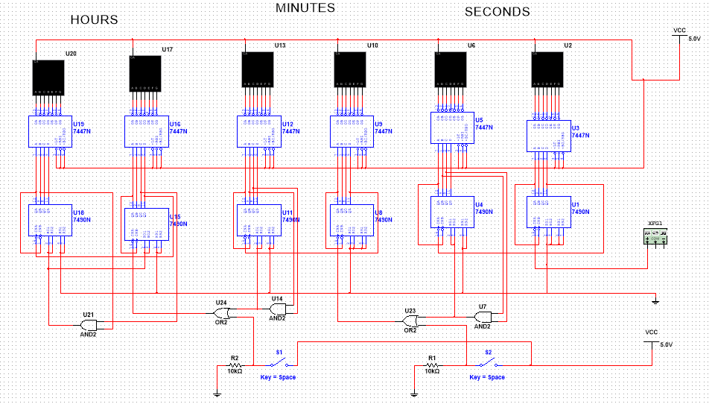

SIMULATION & TESTING IN MULTISIM
In Multisim, we place all the ICs (7490N, 7447N, 7408N, 7432N), 7-segment displays, clock source (set to 1 Hz for normal simulation or faster for testing), switches, and resistors. We wire everything exactly as described, using virtual probes and logic analyzers where helpful.
During simulation, the clock runs smoothly: seconds increment every pulse, roll over at 59 to advance minutes, and hours advance at 59 minutes. The displays update correctly through the 7447 decoders. Manual buttons allow quick time setting without glitches. We test edge cases like rollover from 23:59:59 to 00:00:00 and verify reset logic prevents invalid states like 24 or 60. Waveforms confirm clean clocking and reset pulses.

CONCLUSION
This project successfully demonstrates the design and simulation of a fully functional digital clock in Multisim. We integrated asynchronous counters, custom reset logic for different moduli (mod-60 and mod-24), decoders, and manual controls into one cohesive system.
Key takeaways include a deeper appreciation for how sequential logic (counters) combines with combinational logic (AND/OR gates for decoding and reset) to solve real-world timing problems. The simulation approach proved invaluable for rapid prototyping and debugging. This foundation can be extended to alarm features, 12-hour format, or even hardware implementation on a breadboard or FPGA.

REFERENCES
- Floyd, Thomas L. Digital Fundamentals. Pearson Education.
- Mano, M. Morris, and Ciletti, Michael D. Digital Design. Pearson Education.
- National Instruments. Multisim User Manual.
- Manufacturer datasheets for IC 7490, 7447, 7408, and 7432.

